**I. Static and Default routing using packet tracer**

1. Cabling the network

2. Basic operations on router

3. Configure and activate interfaces

4. Configuring static routing

5. Configuring default route

6. Verify static and default routing using ping commands

Configure the devices with static IP addresses make sure that they can ping any device that is directly connected



**II. Serial Interfacing and IP addressing**

1. Cabling the network

2. Basic operations on router

3. Configure and activate interfaces

4. Setting up serial link with a certain clock speed

1. Configure the devices with serial and static IP addresses make sure that they can ping any device that is connected to the network.

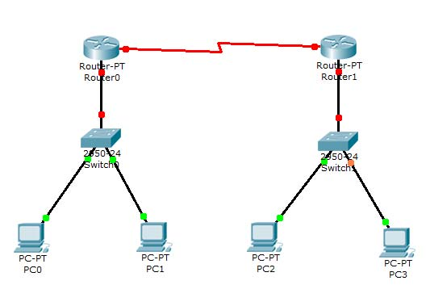

1. Establish a simple serial to serial connection between Router1 and Router2 and Ping from PC0 to PC1

